1. ***GIT AND GITHUB***

***Section-0***

1. shailag@lin80022826 MINGW64 ~

$ mkdir project_dir

mkdir: cannot create directory ‘project_dir’: File exists

shailag@lin80022826 MINGW64 ~

$ cd project_dir

shailag@lin80022826 MINGW64 ~/project_dir (master)

1. shailag@lin80022826 MINGW64 ~/project_dir

$ git init

Initialized empty Git repository in C:/Users/shailag/project_dir/.git/

1. shailag@lin80022826 MINGW64 ~/project_dir (master)

$ touch index.html

shailag@lin80022826 MINGW64 ~/project_dir (master)

1. $ git status

On branch master

No commits yet

Untracked files:

(use "git add <file>..." to include in what will be committed)

index.html

index.txt

nothing added to commit but untracked files present (use "git add" to track)

1. shailag@lin80022826 MINGW64 ~/project_dir (master)

$ git add index.html

shailag@lin80022826 MINGW64 ~/project_dir (master)

1. $ git commit -m"Added index.html"

[master (root-commit) 1ff11cf] Added index.html

Committer: G <shailaja.a.g@capgemini.com>

Your name and email address were configured automatically based

on your username and hostname. Please check that they are accurate.

You can suppress this message by setting them explicitly:

git config --global user.name "Your Name"

git config --global user.email you@example.com

After doing this, you may fix the identity used for this commit with:

git commit --amend --reset-author

1 file changed, 0 insertions(+), 0 deletions(-)

create mode 100644 index.html

shailag@lin80022826 MINGW64 ~/project_dir (master)

1. $ touch info.txt
2. shailag@lin80022826 MINGW64 ~/project_dir (master)

$ git status

On branch master

Changes not staged for commit:

(use "git add <file>..." to update what will be committed)

(use "git restore <file>..." to discard changes in working directory)

modified: index.html

Untracked files:

(use "git add <file>..." to include in what will be committed)

desktop.ini

info.txt

no changes added to commit (use "git add" and/or "git commit -a")

1. shailag@lin80022826 MINGW64 ~/project_dir (master)

$ project_dir/info/exclude.gitignore

bash: project_dir/info/exclude.gitignore: No such file or directory

10. shailag@lin80022826 MINGW64 ~/project_dir (master)

$ git status

On branch master

Changes not staged for commit:

(use "git add <file>..." to update what will be committed)

(use "git restore <file>..." to discard changes in working directory)

modified: index.html

Untracked files:

(use "git add <file>..." to include in what will be committed)

desktop.ini

11. $ git commit -m"Added index.html"

On branch master

Changes not staged for commit:

(use "git add <file>..." to update what will be committed)

(use "git restore <file>..." to discard changes in working directory)

modified: index.html

Untracked files:

(use "git add <file>..." to include in what will be committed)

desktop.ini

12. $ git log

commit 1ff11cf1006f31628daf3c2301a98d508e1483f7 (HEAD -> master)

Author: G <shailaja.a.g@capgemini.com>

Date: Fri Oct 14 11:23:51 2022 +0530

Added index.html

shailag@lin80022826 MINGW64 ~/project_dir (master)

$ git rebase

There is no tracking information for the current branch.

Please specify which branch you want to rebase against.

See git-rebase(1) for details.

git rebase '<branch>'

If you wish to set tracking information for this branch you can do so with:

git branch --set-upstream-to=<remote>/<branch> master

13. shailag@lin80022826 MINGW64 ~/project_dir (master)

$ git checkout index.html

Updated 1 path from the index

shailag@lin80022826 MINGW64 ~/project_dir (master)

$ git log

commit 1ff11cf1006f31628daf3c2301a98d508e1483f7 (HEAD -> master)

Author: G <shailaja.a.g@capgemini.com>

Date: Fri Oct 14 11:23:51 2022 +0530

Added index.html

shailag@lin80022826 MINGW64 ~/project_dir (master)

$ git revert 1ff11cf1006f31628daf3c2301a98d508e1483f7

14. shailag@lin80022826 MINGW64 ~/project_dir (master)

$ git revert 1ff11cf1006f31628daf3c2301a98d508e1483f7

Revert "Added index.html"

This reverts commit 1ff11cf1006f31628daf3c2301a98d508e1483f7.

# Please enter the commit message for your changes. Lines starting

# with '#' will be ignored, and an empty message aborts the commit.

#

# Committer: G <shailaja.a.g@capgemini.com>

#

# On branch master

# Changes to be committed:

# deleted: index.html

#

# Untracked files:

# desktop.ini

16. shailag@lin80022826 MINGW64 ~/project_dir (master)

$ git commit -m"Commiting index.html"

[master 607624c] Commiting index.html

Committer: G <shailaja.a.g@capgemini.com>

Your name and email address were configured automatically based

on your username and hostname. Please check that they are accurate.

You can suppress this message by setting them explicitly:

git config --global user.name "Your Name"

git config --global user.email you@example.com

After doing this, you may fix the identity used for this commit with:

git commit --amend --reset-author

1 file changed, 5 insertions(+)

create mode 100644 index.html

18. shailag@lin80022826 MINGW64 ~/project_dir (master)

$ git config --global alias.myadd add

shailag@lin80022826 MINGW64 ~/project_dir (master)

$

19. shailag@lin80022826 MINGW64 ~/project_dir (master)

$ git myadd index.html

shailag@lin80022826 MINGW64 ~/project_dir (master)

$ git commit -m"Commiting index.html"

[master 607624c] Commiting index.html

Committer: G <shailaja.a.g@capgemini.com>

Your name and email address were configured automatically based

on your username and hostname. Please check that they are accurate.

You can suppress this message by setting them explicitly:

git config --global user.name "Your Name"

git config --global user.email you@example.com

After doing this, you may fix the identity used for this commit with:

git commit --amend --reset-author

1 file changed, 5 insertions(+)

create mode 100644 index.html

shailag@lin80022826 MINGW64 ~/project_dir (master)

$ git status

On branch master

Untracked files:

(use "git add <file>..." to include in what will be committed)

desktop.ini

nothing added to commit but untracked files present (use "git add" to track)

shailag@lin80022826 MINGW64 ~/project_dir (maste

20. shailag@lin80022826 MINGW64 ~/project_dir (master)

$ git checkout index.html

Updated 0 paths from the index

shailag@lin80022826 MINGW64 ~/project_dir (master)

$ git log

commit 607624ccb64ccab876da7f5c74a2109092e2e0f5 (HEAD -> master)

Author: G <shailaja.a.g@capgemini.com>

Date: Sat Oct 15 00:09:49 2022 +0530

Commiting index.html

commit 93b76e3ddca5745e4ad3c02739e69b2efe14c4ed

Author: G <shailaja.a.g@capgemini.com>

Date: Fri Oct 14 23:48:40 2022 +0530

Revert "Added index.html"

This reverts commit 1ff11cf1006f31628daf3c2301a98d508e1483f7.

commit 1ff11cf1006f31628daf3c2301a98d508e1483f7

Author: G <shailaja.a.g@capgemini.com>

Date: Fri Oct 14 11:23:51 2022 +0530

Added index.html

shailag@lin80022826 MINGW64 ~/project_dir (master)

$ git revert 1ff11cf1006f31628daf3c2301a98d508e1483f7

***GIT -BRANCHING***

***SECTION-1 HTML ASSIGNMENTS***

22. shailag@lin80022826 MINGW64 ~

$ mkdir Assignments

shailag@lin80022826 MINGW64 ~

$ cd Assignments

shailag@lin80022826 MINGW64 ~/Assignments

$ git init

Initialized empty Git repository in C:/Users/shailag/Assignments/.git/

23. shailag@lin80022826 MINGW64 ~/Assignments (master)

$ touch README.txt

shailag@lin80022826 MINGW64 ~/Assignments (master)

$ git add README.txt

shailag@lin80022826 MINGW64 ~/Assignments (master)

$ git status

On branch master

No commits yet

Changes to be committed:

(use "git rm --cached <file>..." to unstage)

new file: README.txt

shailag@lin80022826 MINGW64 ~/Assignments (master)

24. shailag@lin80022826 MINGW64 ~/Assignments (master)

$ git add README.txt

shailag@lin80022826 MINGW64 ~/Assignments (master)

$ git commit -m"Added text ti README.txt"

[master (root-commit) d0ef734] Added text ti README.txt

Committer: G <shailaja.a.g@capgemini.com>

Your name and email address were configured automatically based

on your username and hostname. Please check that they are accurate.

You can suppress this message by setting them explicitly:

git config --global user.name "Your Name"

git config --global user.email you@example.com

After doing this, you may fix the identity used for this commit with:

git commit --amend --reset-author

1 file changed, 1 insertion(+)

create mode 100644 README.txt

shailag@lin80022826 MINGW64 ~/Assignments (master)

$

25. shailag@lin80022826 MINGW64 ~/Assignments (master)

$ git branch html-assignments

shailag@lin80022826 MINGW64 ~/Assignments (master)

$ git branch html_assignments

shailag@lin80022826 MINGW64 ~/Assignments (master)

$ git merge master

Already up to date.

shailag@lin80022826 MINGW64 ~/Assignments (master)

$ git commit -m"html assignments in Html Assignments branch"

On branch master

nothing to commit, working tree clean

shailag@lin80022826 MINGW64 ~/Assignments (master)

$ git branch html

shailag@lin80022826 MINGW64 ~/Assignments (master)

$ git merge master

Already up to date.

shailag@lin80022826 MINGW64 ~/Assignments (master)

$ git branch

html

html-assignments

html_assignments

* master

26. shailag@lin80022826 MINGW64 ~/Assignments (master)

$ git checkout -b html_assignments

fatal: a branch named 'html_assignments' already exists

**27**.shailag@lin80022826 MINGW64 ~/Assignments (master)

$ git merge master

Already up to date.

**28**.shailag@lin80022826 MINGW64 ~/Assignments (master)

$ git commit -m"html_assignments commited"

On branch master

nothing to commit, working tree clean.

29. shailag@lin80022826 MINGW64 ~/Assignments (master)

$ touch html.txt

**30**.shailag@lin80022826 MINGW64 ~/Assignments (master)

$ git commit -a

On branch master

Untracked files:

(use "git add <file>..." to include in what will be committed)

html.txt

shailag@lin80022826 MINGW64 ~/Assignments (master)

$ git commit -a

On branch master

Untracked files:

(use "git add <file>..." to include in what will be committed)

html.txt

nothing added to commit but untracked files present (use "git add" to track)

nothing added to commit but untracked files present (use "git add" to track)

31. shailag@lin80022826 MINGW64 ~/Assignments (master)

$ git checkout master

Already on 'master'

shailag@lin80022826 MINGW64 ~/Assignments (master)

33. shailag@lin80022826 MINGW64 ~/Assignments (master)

$ git checkout html_assignments

Switched to branch 'html_assignments'

34. $ git status

On branch html_assignments

Untracked files:

(use "git add <file>..." to include in what will be committed)

html.txt

nothing added to commit but untracked files present (use "git add" to track)

**35.**shailag@lin80022826 MINGW64 ~/Assignments (html_assignments)

$ git commit -m"htmls assignments modified"

On branch html_assignments

Untracked files:

(use "git add <file>..." to include in what will be committed)

html.txt

nothing added to commit but untracked files present (use "git add" to track)

shailag@lin80022826 MINGW64 ~/Assignments (html_assignments)

36. shailag@lin80022826 MINGW64 ~/Assignments (html_assignments)

$ git checkout master

Switched to branch 'master'

shailag@lin80022826 MINGW64 ~/Assignments (master)

37. shailag@lin80022826 MINGW64 ~/Assignments (html_assignments)

$ git checkout master

Switched to branch 'master'

shailag@lin80022826 MINGW64 ~/Assignments (master)

$ git merge html_assignments

Already up to date.

shailag@lin80022826 MINGW64 ~/Assignments (master)

$ git branch

html

html-assignments

html_assignments

* master

shailag@lin80022826 MINGW64 ~/Assignme

**38.** shailag@lin80022826 MINGW64 ~/Assignments (html_assignments)

$ git checkout master

Switched to branch 'master'

shailag@lin80022826 MINGW64 ~/Assignments (master)

$ git branch -d html_assignments

Deleted branch html_assignments (was d0ef734).

shailag@lin80022826 MINGW64 ~/Assignments (master)

***SECTION-2 CSS-ASSIGNMENTS***

1. $ cd Assignments

shailag@lin80022826 MINGW64 ~/Assignments (master)

$ git init

Reinitialized existing Git repository in C:/Users/shailag/Assignments/.git/

shailag@lin80022826 MINGW64 ~/Assignments (master)

$ git branch css_assignments

1. shailag@lin80022826 MINGW64 ~/Assignments (master)

$ git checkout css_assignments

Switched to branch 'css_assignments'

$ git commit -m"commiting css assignments"

**4**.@lin80022826 MINGW64 ~/Assignments (css_assignments)

$ git commit -m"commiting css assignments"

On branch css_assignments

Untracked files:

(use "git add <file>..." to include in what will be committed)

html.txt

m1.txt

m2.txt

nothing added to commit but untracked files present (use "git add" to track)

5. shailag@lin80022826 MINGW64 ~/Assignments (css_assignments)

$ git status

On branch css_assignments

Changes not staged for commit:

(use "git add <file>..." to update what will be committed)

(use "git restore <file>..." to discard changes in working directory)

modified: README.txt

Untracked files:

(use "git add <file>..." to include in what will be committed)

html.txt

m1.txt

m2.txt

6. shailag@lin80022826 MINGW64 ~/Assignments (css_assignments)

$ git status

On branch css_assignments

Changes not staged for commit:

(use "git add <file>..." to update what will be committed)

(use "git restore <file>..." to discard changes in working directory)

modified: README.txt

Untracked files:

(use "git add <file>..." to include in what will be committed)

html.txt

m1.txt

m2.txt

7. shailag@lin80022826 MINGW64 ~/Assignments (css_assignments)

$ git checkout master

Switched to branch 'master'

M README.txt

shailag@lin80022826 MINGW64 ~/Assignments (master)

$

8. shailag@lin80022826 MINGW64 ~/Assignments (master)

$ git commit -m"README.txt line 3 modified"

On branch master

Changes not staged for commit:

(use "git add <file>..." to update what will be committed)

(use "git restore <file>..." to discard changes in working directory)

modified: README.txt

Untracked files:

(use "git add <file>..." to include in what will be committed)

html.txt

m1.txt

m2.txt

no changes added to commit (use "git add" and/or "git commit -a")

9. $ git checkout css_assignments

Switched to branch 'css_assignments'

M README.txt

shailag@lin80022826 MINGW64 ~/Assignments (css_assignments)

$

10. shailag@lin80022826 MINGW64 ~/Assignments (css_assignments)

$ git commit -m"m1.txt file modified"

On branch css_assignments

Changes not staged for commit:

(use "git add <file>..." to update what will be committed)

(use "git restore <file>..." to discard changes in working directory)

modified: m1.txt

Untracked files:

(use "git add <file>..." to include in what will be committed)

html.txt

m1.txt

m2.txt

11. shailag@lin80022826 MINGW64 ~/Assignments (css_assignments)

$ git commit -m"m1.txt file modified"

On branch css_assignments

Changes not staged for commit:

(use "git add <file>..." to update what will be committed)

(use "git restore <file>..." to discard changes in working directory)

modified: m1.txt

Untracked files:

(use "git add <file>..." to include in what will be committed)

html.txt

m1.txt

m2.txt

12. shailag@lin80022826 MINGW64 ~/Assignments (css_assignments)

$ git checkout master

Switched to branch 'master'

M README.txt

shailag@lin80022826 MINGW64 ~/Assignments (master)

13. $ git merge css_assignments

Already up to date.

shailag@lin80022826 MINGW64 ~/Assignments (master)

$ git branch

css_assignments

html

html-assignments

* master

shailag@lin80022826 MINGW64 ~/Assignments (master)

14. $ git branch -d css_assignments

Deleted branch css_assignments (was d0ef734).

shailag@lin80022826 MINGW64 ~/Assignments (master)

$

***Section -3 JavaScript Assignments***

1. shailag@lin80022826 MINGW64 ~/Assignments (master)

$ git branch js_assignments

shailag@lin80022826 MINGW64 ~/Assignments (master)

2. shailag@lin80022826 MINGW64 ~/Assignments (master)

$ git checkout js_assignments

Switched to branch 'js_assignments'

M README.txt

shailag@lin80022826 MINGW64 ~/Assignments (js_assignments)

$

3. $ git commit -m"Added to js"

On branch js_assignments

Changes not staged for commit:

(use "git add <file>..." to update what will be committed)

(use "git restore <file>..." to discard changes in working directory)

modified: README.txt

Untracked files:

(use "git add <file>..." to include in what will be committed)

html.txt

m1.txt

m2.txt

4. $ git commit -m"Added to js"

On branch js_assignments

Changes not staged for commit:

(use "git add <file>..." to update what will be committed)

(use "git restore <file>..." to discard changes in working directory)

modified: README.txt

Untracked files:

(use "git add <file>..." to include in what will be committed)

html.txt

m1.txt

m2.txt

6. shailag@lin80022826 MINGW64 ~/Assignments (js_assignments)

$ git commit -m "Modified README.txtin js assignment"

On branch js_assignments

Changes not staged for commit:

(use "git add <file>..." to update what will be committed)

(use "git restore <file>..." to discard changes in working directory)

modified: README.txt

Untracked files:

(use "git add <file>..." to include in what will be committed)

html.txt

m1.txt

m2.txt

7. shailag@lin80022826 MINGW64 ~/Assignments (js_assignments)

$ git checkout master

Switched to branch 'master'

M README.txt

shailag@lin80022826 MINGW64 ~/Assignments (master)

$

8. shailag@lin80022826 MINGW64 ~/Assignments (master)

$ git commit -m "README.txt line 1 modified"

On branch master

Changes not staged for commit:

(use "git add <file>..." to update what will be committed)

(use "git restore <file>..." to discard changes in working directory)

modified: README.txt

Untracked files:

(use "git add <file>..." to include in what will be committed)

html.txt

m1.txt

m2.txt

no changes added to commit (use "git add" and/or "git commit -a")

shailag@lin80022826 MINGW64 ~/Assignments (master)

$

9. shailag@lin80022826 MINGW64 ~/Assignments (master)

$ git checkout js_assignments

Switched to branch 'js_assignments'

M README.txt

shailag@lin80

10. shailag@lin80022826 MINGW64 ~/Assignments (js_assignments)

$ git commit -m "Modified README.txtin js assignment"

On branch js_assignments

Changes not staged for commit:

(use "git add <file>..." to update what will be committed)

(use "git restore <file>..." to discard changes in working directory)

modified: m2.txt

Untracked files:

(use "git add <file>..." to include in what will be committed)

html.txt

m1.txt

shailag@lin80022826 MINGW64 ~/Assignments (js_assignments)

11. . shailag@lin80022826 MINGW64 ~/Assignments (js_assignments)

$ git commit -m "Modified README.txtin js assignment"

On branch js_assignments

Changes not staged for commit:

(use "git add <file>..." to update what will be committed)

(use "git restore <file>..." to discard changes in working directory)

modified: m2.txt

Untracked files:

(use "git add <file>..." to include in what will be committed)

html.txt

m1.txt

shailag@lin80022826 MINGW64 ~/Assignments (js_assignments)

12. shailag@lin80022826 MINGW64 ~/Assignments (js_assignments)

$ git checkout master

Switched to branch 'master'

13. shailag@lin80022826 MINGW64 ~/Assignments (master)

$ git merge js_assignments

Already up to date.

shailag@lin80022826 MINGW64 ~/Assignments (master)

$ git branch

html

html-assignments

js_assignments

* master

shailag@lin80022826 MINGW64 ~/Assignments (master)

$

14. shailag@lin80022826 MINGW64 ~/Assignments (master)

$ git branch -d js_assignments

Deleted branch js_assignments (was d0ef734).

shailag@lin80022826 MINGW64 ~/Assignments (master)

$

***Git-Remoting***

***Section-3***

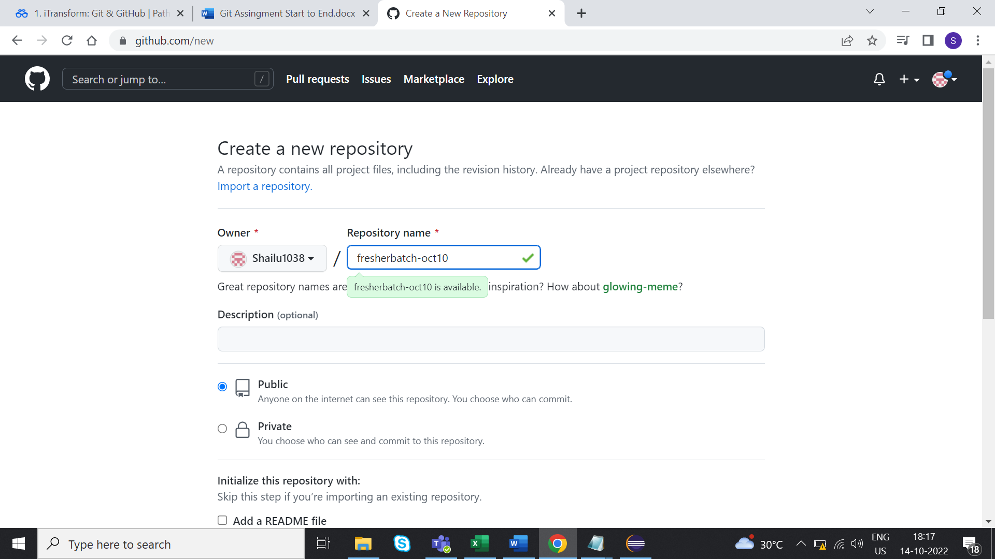

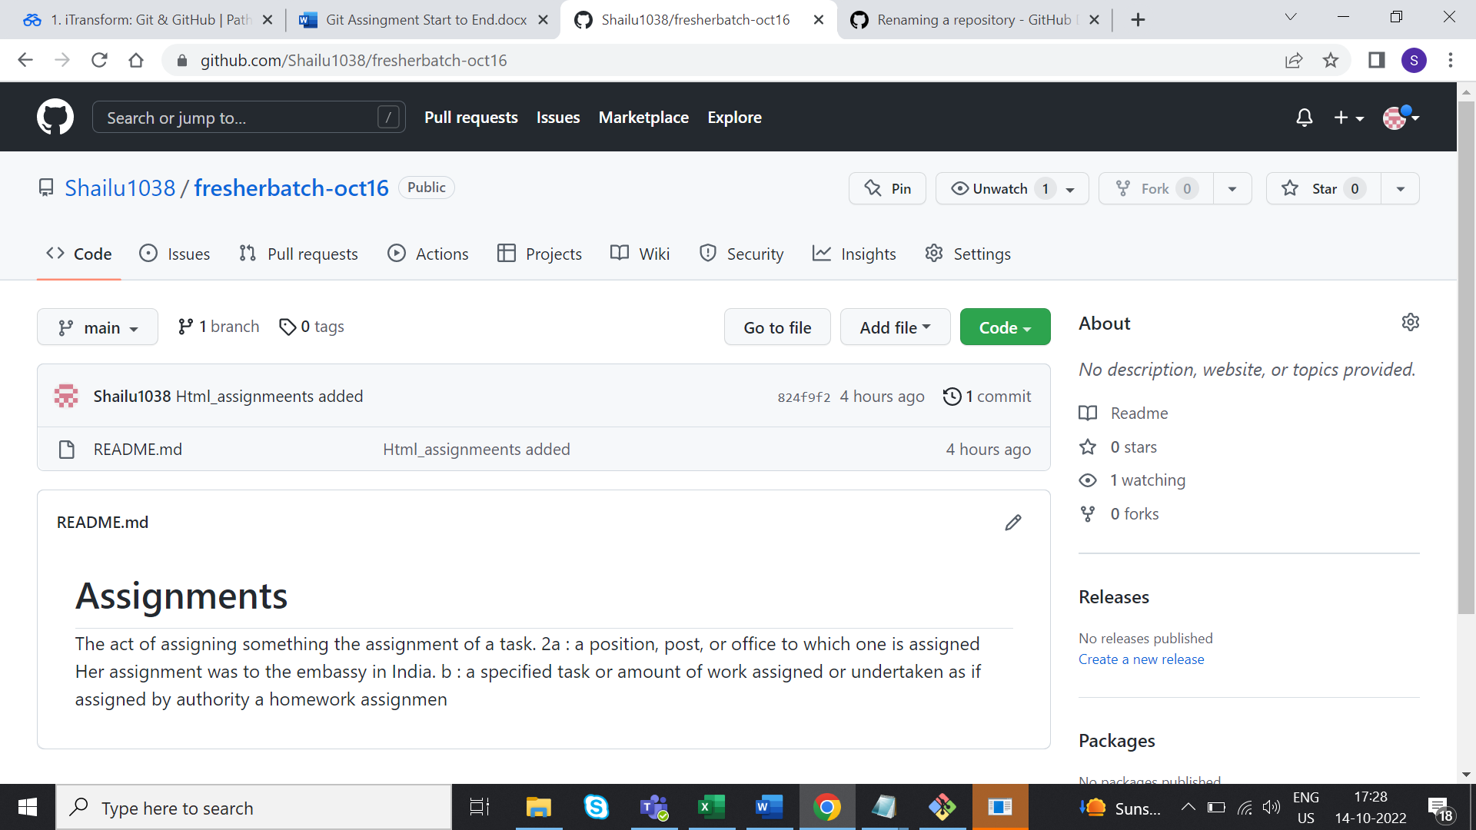

***Section -4***

